Underlying NBBO for COB Cross Product Spread

Overview

Current processing
None.

New requirement
- In COB for cross product spreads project, CBOEDirect will implement a “best effort strategy”, where CBOEDirect will monitor NBBO/BOTRs in all cross product spread legs, including the equity leg, for triggering the reCOA process of the booked cross product spread orders.

Implementation
- Currently HybridTradeServer receives BOTR for option products, and caches them; option NBBO is calculated only when there is such request; however, no underlying NBBO data is sent to HybridTradeServer.
- For this project, XTP BC will send underlying NBBO to HybridTradeServer through event channel BestOfTheRest (or some new channel):
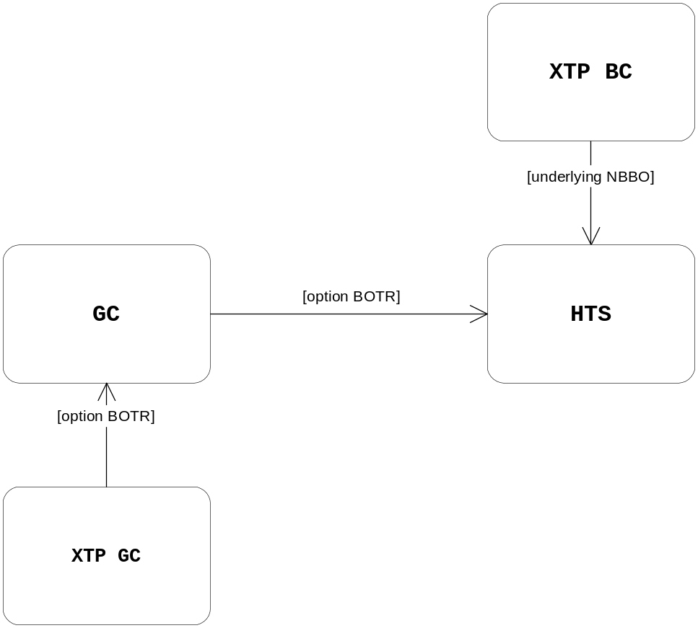
- Add a new interface UnderlyingNBBODataConsumer so that it will share the BOTR event channel with interface BestOfTheRestConsumer (INFRA needs to make change so that for BOTR channel, the connection will be per topic):
interface BestOfTheRestConsumer {
void acceptBestOfTheRest(in cmiUtil::LongSequence groups, in quote::ExternalQuoteSideStructSequence bestOfRestQuote );
void acceptExchangeIndicators(in util::RoutingParameterStruct routingParameters, in exchange::ExchangeClassIndicatorStructSequence exchangeIndicator);
void acceptMarketDataBuffer(in product::GroupKey groupKey, in long subIdentifier, in util::OctetSequence buffer);
};
interface UnderlyingNBBODataConsumer {
void acceptUnderlyingNBBODataBuffer(in product::GroupKey groupKey, in long subIdentifier, in util::OctetSequence buffer);
};
- The underlying NBBO data layout will be:
int productKey
int classKey
int reportingClassKey
byte nbboOrCBSX
int bidPrice
int bidVolume
int askPrice
int askVolume
- ReCOAMonitoringService will implement UnderlyingNBBODataConsumer, where method “void acceptUnderlyingNBBODataBuffer()” will be implemented.
- When ReCOAMonitoringService receives the underlying NBBO from XTP and option BOTR data, it will evaluate and process reCOA of the booked CPS orders.

Scripts
- None

Database
- None

SetContext
- None

XML/DTD
- None

Trading Property
- None

Homes/Services
- None

ImplPlan
- None

PerformanceTestingProcedure
- None

TestingProcedure
- None

OperatorProcedure
- None

Fallback/Failover
- None

